ANALYSIS OF PRODUCT PRICING, DISCOUNTS, AND INVENTORY USING SQL:
A CASE STUDY ON ZEPTO GROCERY DATA**
Presented By Shantanu Roy

Abstract
In the rapidly growing quick-commerce industry, efficient pricing, discount strategies, and inventory management play a crucial role in maintaining profitability and customer satisfaction. This project presents a comprehensive SQL-based analysis of product data from Zepto, an instant grocery delivery platform. The study focuses on exploring product categories, pricing structures, discount patterns, stock availability, and estimated revenue generation. Using structured query language (SQL), raw data was cleaned, transformed, and analyzed to derive actionable business insights. The results of this analysis help identify high-value products, revenue-generating categories, stock inefficiencies, and pricing opportunities. This project demonstrates how SQL can be effectively used as a core analytical tool for real-world business decision-making.

1. Introduction
With the rise of instant delivery platforms such as Zepto, Blinkit, and Swiggy Instamart, data-driven decision-making has become essential for managing thousands of products in real time. These platforms rely heavily on accurate pricing, effective discount strategies, and optimal inventory levels to remain competitive.
This project aims to analyze Zepto’s grocery product data using SQL to understand how discounts, pricing, product weight, and availability influence revenue and inventory distribution. The project simulates a real-world data analyst role where raw data is transformed into meaningful insights for business stakeholders.

2. Problem Statement
Zepto manages a wide variety of grocery products across multiple categories. However, challenges such as:
- Products with high prices but low availability
- Inconsistent discount strategies
- Overstocking or understocking of products
- Difficulty identifying best-value products
can negatively impact revenue and customer experience.
The problem addressed in this project is how to efficiently analyze pricing, discounts, and inventory data using SQL to support better business decisions.

3. Objectives of the Study
The primary objectives of this project are:
- To explore and clean the Zepto product dataset.
- To analyze product categories and stock availability.
- To identify top discounted and best-value products.
- To calculate estimated revenue by product category.
- To evaluate inventory distribution based on product weight.
- To provide data-driven business recommendations using SQL insights.

4. Dataset Description
The dataset consists of grocery product data with the following attributes:
Column Name | Description
sku_id | Unique identifier for each product
category | Product category
name | Product name
mrp | Maximum Retail Price
discountPercent | Discount percentage applied
availableQuantity | Quantity available in inventory
discountedSellingPrice | Final selling price after discount
weightInGms | Product weight in grams
outOfStock | Stock status
quantity | Units per SKU
The dataset primarily focuses on the Fruits & Vegetables category, providing detailed insights into pricing and inventory behavior.

5. Tools & Technologies Used
- Database: PostgreSQL / MySQL
- Query Language: SQL
- IDE: VS Code / pgAdmin
- Data Source: CSV file (Zepto grocery data)
- Documentation: MS Word / Google Docs

6. Methodology
6.1 Data Loading
The dataset was imported into a SQL database by creating a structured table using appropriate data types.
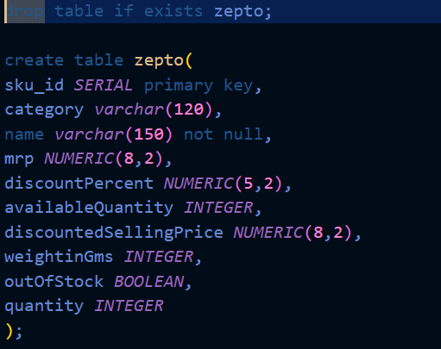

6.2 Data Exploration
Initial exploration included:
- Counting total records
- Viewing sample rows
- Identifying unique categories
- Checking stock distribution
- -- data exploration

- --count of rows
- select count(*) from zepto;

- -- sample data
- select * from zepto
- limit 10;

- -- null values
- select * from zepto
- WHERE name is NULL
- or
- category is NULL
- or
- mrp is NULL
- or
- discountPercent is NULL
- or
- discountedSellingPrice is NULL
- or
- weightInGms is NULL
- or
- availableQuantity is NULL
- or
- outOfStock is NULL
- or
- quantity is NULL;

- -- different Product Categories
- select DISTINCT category
- from zepto
- order by category;

- -- products in Sock vs out of stock
- select outOfStock, COUNT(sku_id)
- from zepto
- group by OutOfStock;

- -- product names present multiple times
- select name, count(sku_id) as "Number of SKUs"
- from zepto
- group by name
- having count(sku_id) > 1
- order by count(sku_id) DESC;

6.3 Data Cleaning
Key cleaning steps included:
- Removing rows with zero pricing values
- Converting price values from paise to rupees
- Identifying duplicate product names with multiple SKUs
- Checking and handling null values
- -- data cleaning

- -- products with price = 0
- select * from zepto
- where mrp = 0 or discountedSellingPrice = 0;
- -- this missing row not possible in data so delete this
- delete from zepto
- where mrp = 0;
- -- convert paise to rupees
- UPDATE zepto
- set mrp = mrp/100.0,
- discountedSellingPrice = discountedSellingPrice/100.0;
- -- checking the conversion from paise o rs
- select mrp, discountedSellingPrice from Zepto;

7. Data Analysis & Results
7.1 Product Category Analysis
The dataset revealed that all products belonged to the Fruits & Vegetables category, emphasizing Zepto’s strong focus on fresh produce.

--Q1. Find top 10 best value products based on the discount percentage.
select DISTINCT name, mrp, discountPercent
from zepto
order by discountPercent DESC
Limit 10;
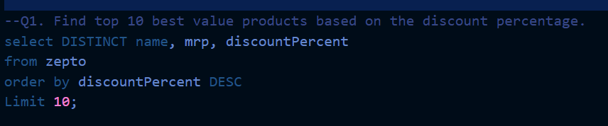

7.2 Stock Availability Analysis
Products were grouped by stock status to identify how many items were available versus out of stock.
This helps operations teams manage replenishment strategies.
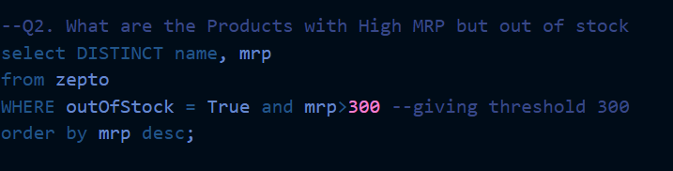

7.3 Top Discounted Products
The analysis identified the top 10 products offering the highest discount percentages, helping marketing teams promote best-value items to customers.

7.4 High MRP but Out-of-Stock Products
Products with MRP greater than ₹300 and marked out of stock were identified.
These items represent missed revenue opportunities and require immediate inventory attention.

7.5 Revenue Estimation by Category
Estimated revenue was calculated using:
discountedSellingPrice × availableQuantity
This analysis highlights which product categories contribute the most to overall revenue.
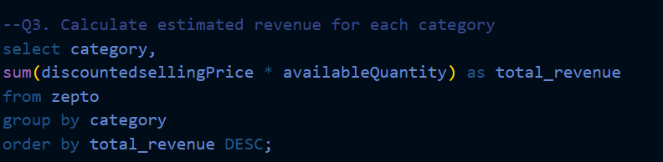

7.6 Low Discount on High-Priced Products
Products priced above ₹500 with discounts below 10% were identified, revealing opportunities for:
- Promotional offers
- Dynamic pricing strategies
- --Q4. Find all products where MRP is greater than 500 and discount
- --is less than 10%
- select DISTINCT name, mrp, discountPercent
- from zepto
- where mrp > 500 and discountPercent < 10
- order by mrp DESC, discountPercent DESC;

7.7 Average Discount by Category
Categories were ranked based on average discount percentage, helping understand pricing competitiveness across products.
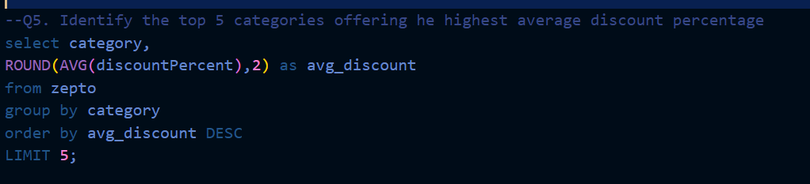

7.8 Price per Gram Analysis
Price per gram was calculated to identify best-value products, enabling customers and businesses to compare items fairly regardless of package size.
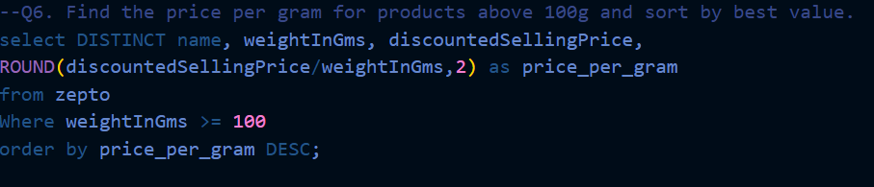

7.9 Weight-Based Product Classification
Products were classified into:
- Low weight
- Medium weight
- Bulk weight
This segmentation supports logistics planning and warehouse optimization.
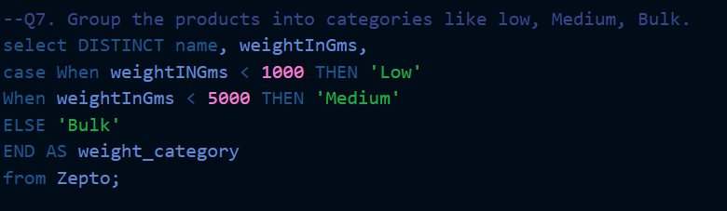

7.10 Total Inventory Weight
Total inventory weight per category was calculated to understand storage and transportation requirements.
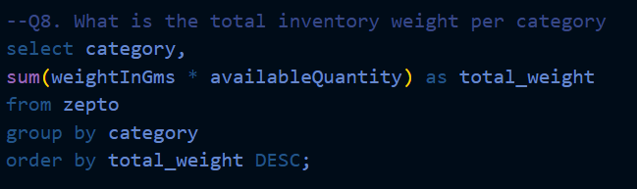

8. Business Insights
- Certain products offer significantly higher discounts, making them ideal for promotional campaigns.
- High-MRP products going out of stock can result in substantial revenue loss.
- Bulk-weight products dominate inventory weight and require optimized logistics.
- Price-per-gram analysis reveals hidden value differences among similar products.
- Categories with higher average discounts attract more price-sensitive customers.

9. Recommendations
- Improve restocking for high-priced out-of-stock products.
- Use discount data to optimize promotional strategies.
- Monitor price-per-gram metrics to maintain competitive pricing.
- Optimize warehouse space based on inventory weight distribution.
- Apply dynamic discounting for low-performing high-MRP products.

10. Conclusion
This project demonstrates how SQL can be effectively used to transform raw grocery data into meaningful business insights. By analyzing pricing, discounts, inventory levels, and revenue potential, the study highlights critical areas where data-driven decisions can enhance profitability and operational efficiency. The Zepto case study serves as a practical example of how structured data analysis supports real-world e-commerce and quick-commerce operations.

11. Future Scope
- Integration with Power BI or Tableau dashboards
- Time-based sales trend analysis
- Predictive inventory forecasting
- Customer purchase behavior analysis
- Automated SQL reporting pipelines

12. References
- PostgreSQL Documentation
- SQL for Data Analysis – Mode Analytics
- E-commerce Pricing Strategy Research Papers
- Zepto Public Platform Insights

